Station 1 Advancements and Technology 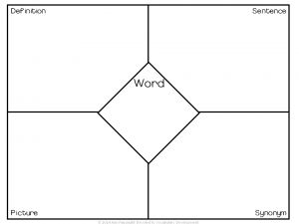
- What is a natural barrier?
- Name one of China’s natural barriers.
- What scientific and cultural contributions did the ancient Chinese make? How are these important to modern civilizations?
- ______ , ___________, __________, and the ________ were major contributions of Ancient ______ and are all still in use today.
- Was gun powder created to help the Chinese win wars? Why or why not?
- What important product did all the people surrounding China want? Why do you think this product is important to trade?
- Why did the Chinese invent Fireworks?
- The first _______ was a ladle-like _______ on a plate with the ______ of the ladle pointing to the ______. Eventually it turned into the ________ _________ ________ we know today.
- Write a one sentence summary describing the advancements and technology of Ancient China.
- Use the Frayer model to explain the word Abacus.

